

National Textile University

**Department of Computer Science**

Subject:

Operating System

Submitted to:

Sir Nasir Mehmood

Submitted by:

Fizza Shameen

Reg number:

23-NTU-CS-1157

Lab no. :

2

Semester:

5th

**Operating Systems – COC 3071L**

**SE 5th A – Fall 2025**

# Lab 2: Linux Basics and Introduction

## Part 1: Linux Environment Orientation

### 1.1 Understanding the Linux Environment

**Concepts to Cover:**

What is Linux? Brief history and distributions

Linux vs Windows: Key differences

Understanding the shell (bash)

WSL2 as a Linux environment

**Hands-on Activity:**

#

S

tudents

open

WSL

2

termin

a

l

a

nd

explore

who

a

mi

#

C

he

c

k

c

urrent

user

pwd

#

P

rint

working

dire

c

tory

un

a

me

-

a

#

S

ystem

inform

a

tion

d

a

te

#

C

urrent

d

a

te

a

nd

time

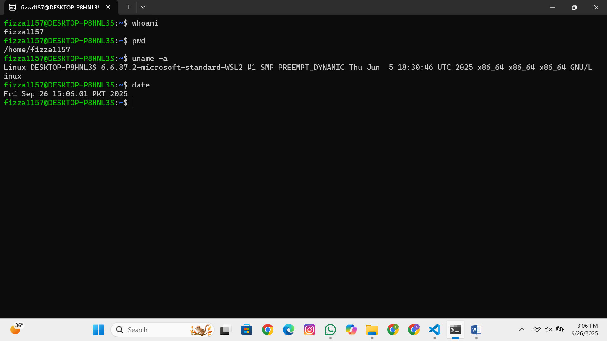

### 1.2 Getting Help in Linux

**Commands to demonstrate:**

m

a

n

ls

#

Ma

nu

a

l

p

a

ges

ls

--

help

#

B

uilt

-

in

help

whi

c

h

ls

#

L

o

ca

tion

of

c

omm

a

nds

type

ls

#

C

omm

a

nd

type

inform

a

tion

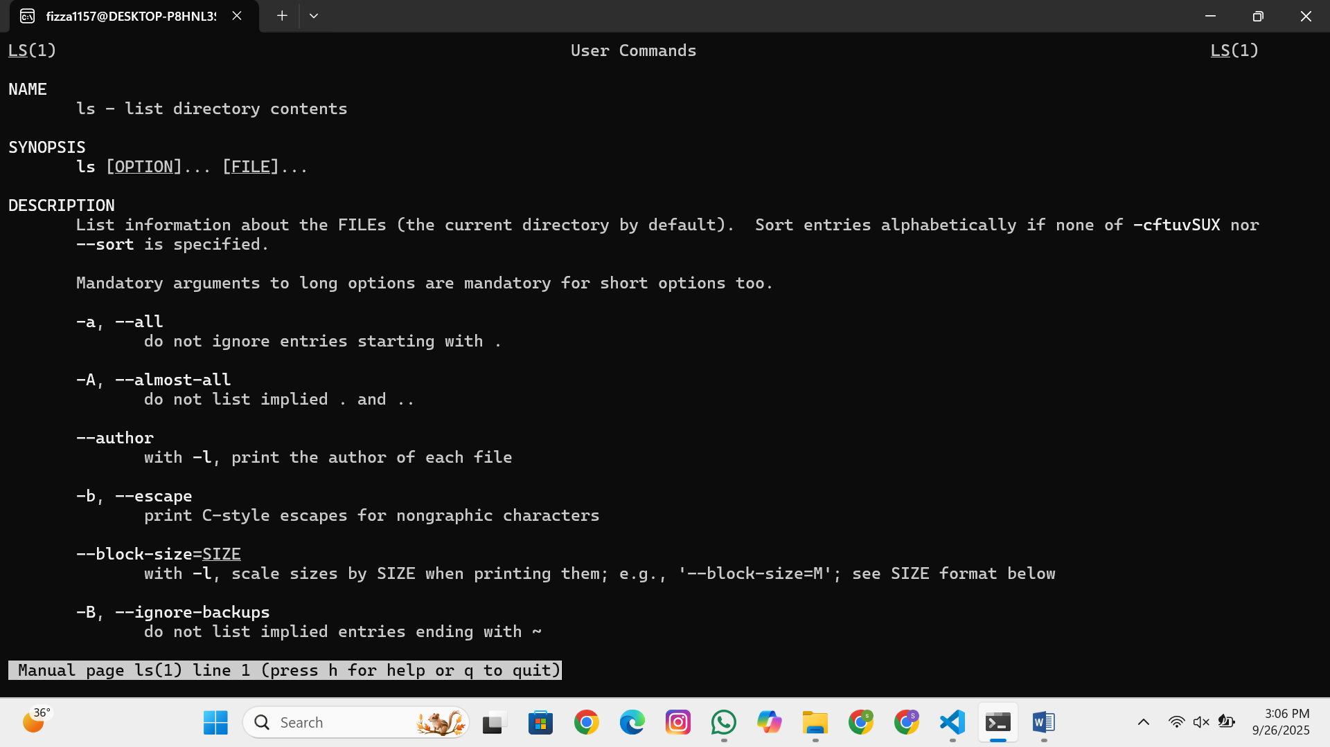

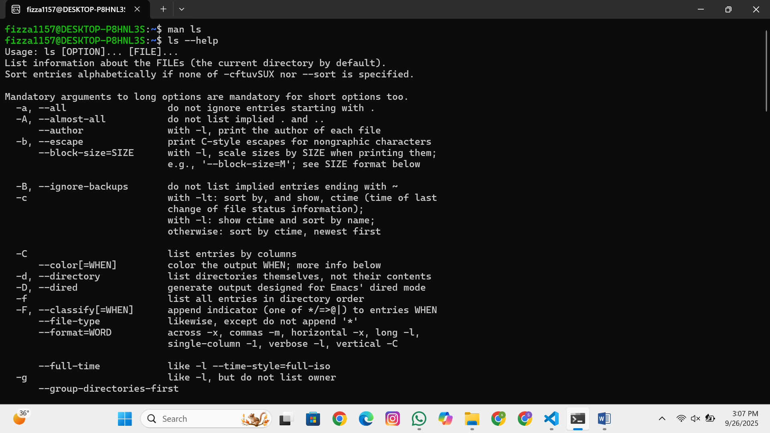

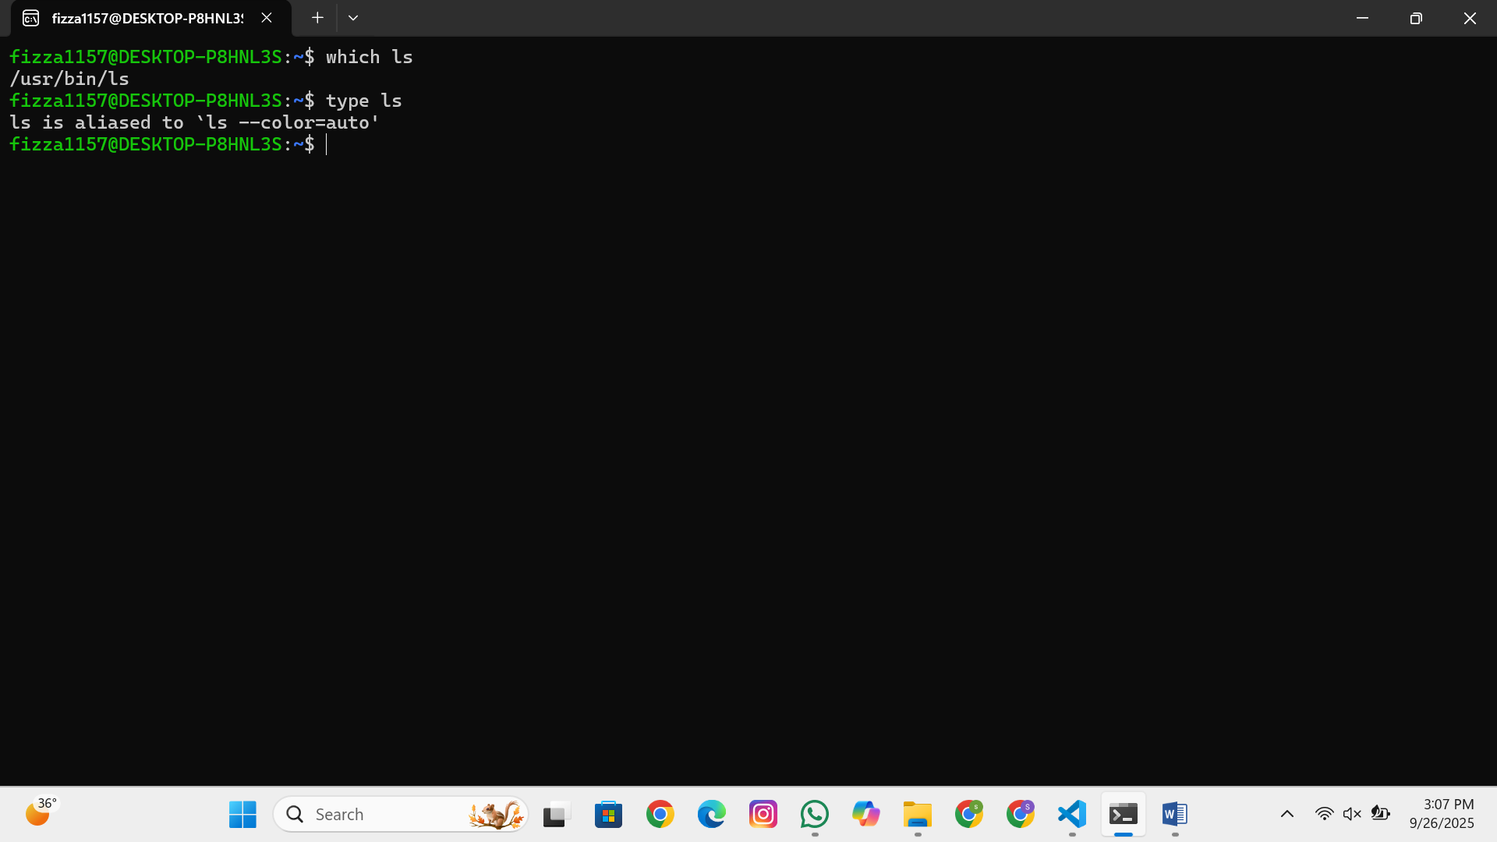

## Part 2: File System Navigation

### 2.1 Understanding Linux Directory Structure

**Concepts to Cover:**

Root directory (/)

Important directories: /home, /usr, /etc, /var, /tmp

Absolute vs relative paths

Hidden files and directories

**Demonstration:**

ls

/

#

R

oot

dire

c

tory

c

ontents

ls

-

l

a

#

L

ong

listing

with

hidden

files

c

d

/

home

#

C

h

a

nge

dire

c

tory

c

d

~

#

H

ome

dire

c

tory

short

c

ut

c

d

-

#

P

revious

dire

c

tory

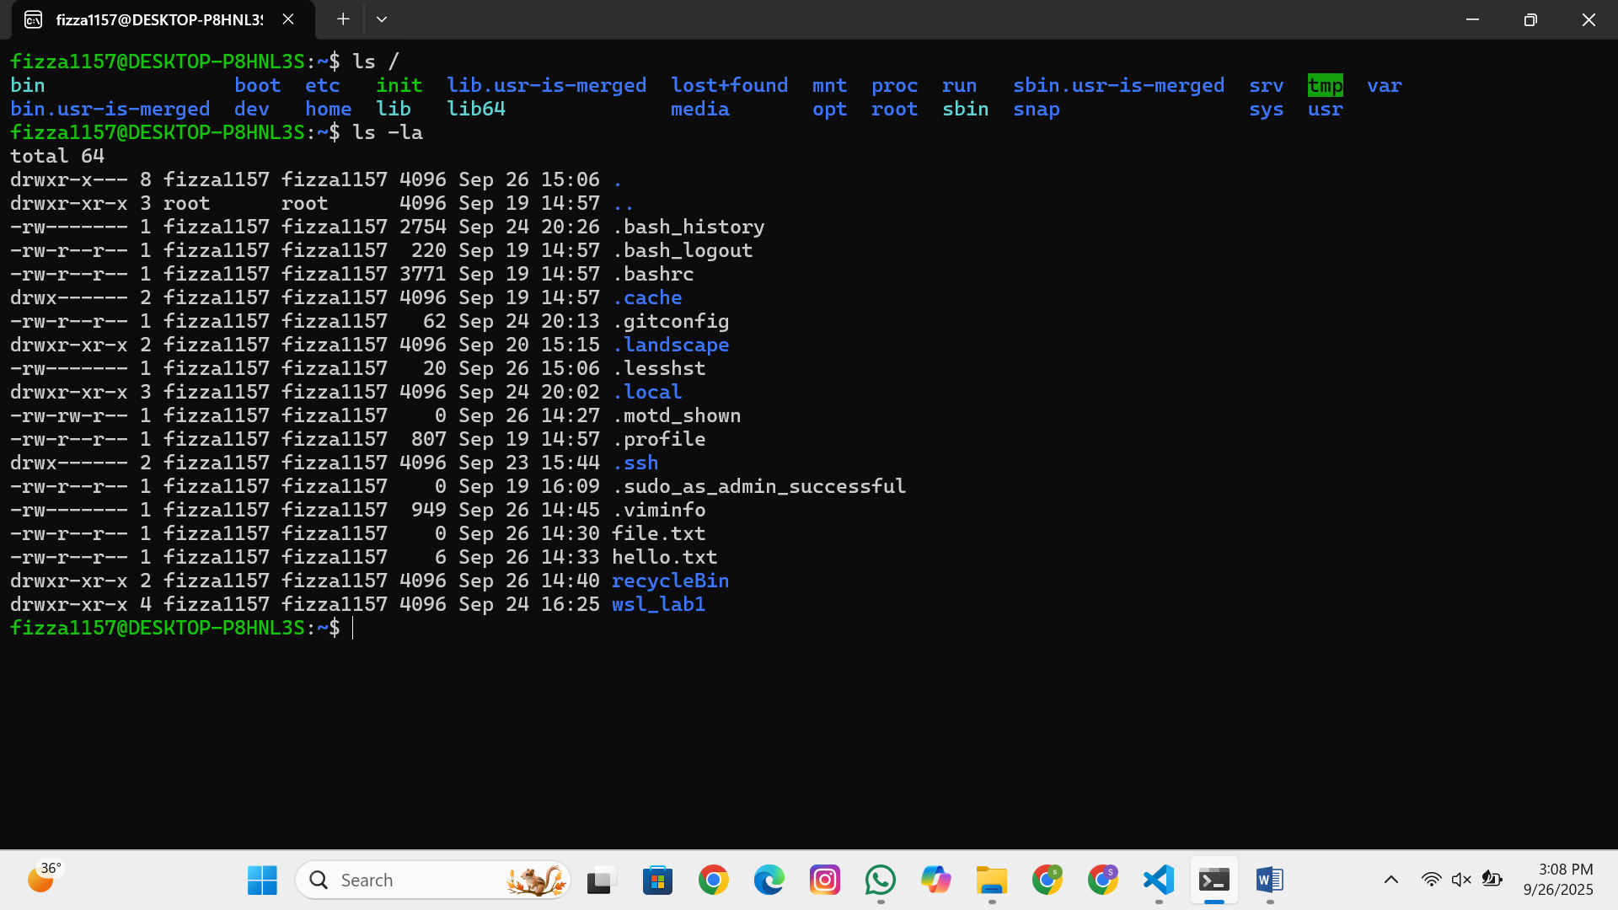

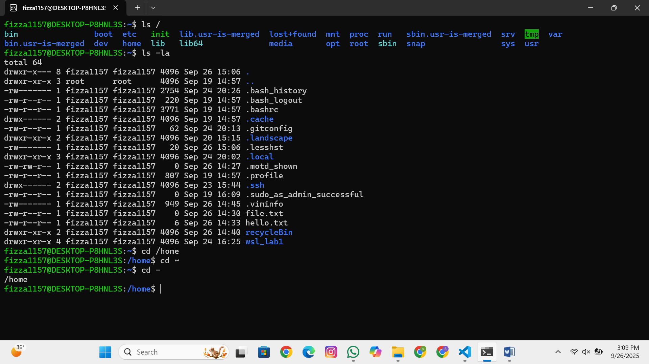

### 2.2 Basic Navigation Commands (15 minutes)

**Commands to practice:**

pwd

#

P

resent

working

dire

c

tory

ls

#

L

ist

dire

c

tory

c

ontents

ls

-

l

#

L

ong

form

a

t

ls

-

l

a

#

I

n

c

lude

hidden

files

ls

-

lh

#

H

um

a

n

re

a

d

ab

le

sizes

c

d

#

C

h

a

nge

dire

c

tory

c

d

..

#

Pa

rent

dire

c

tory

c

d

~

#

H

ome

dire

c

tory

c

d

/

#

R

oot

dire

c

tory

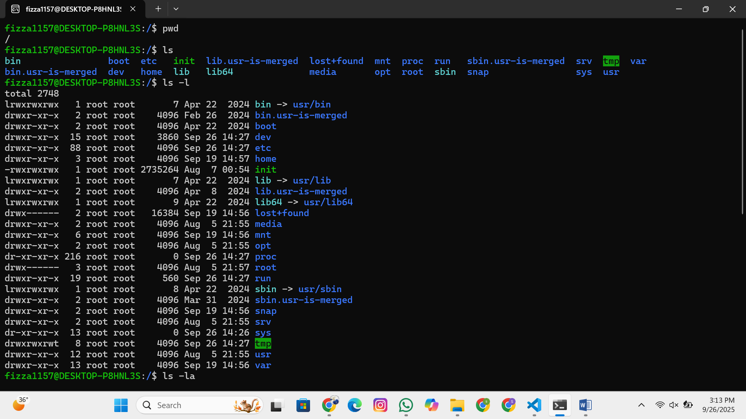

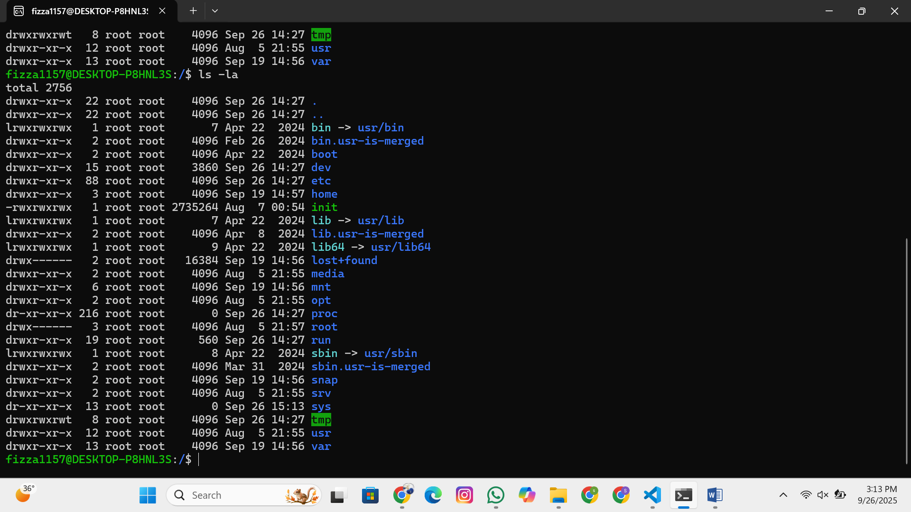

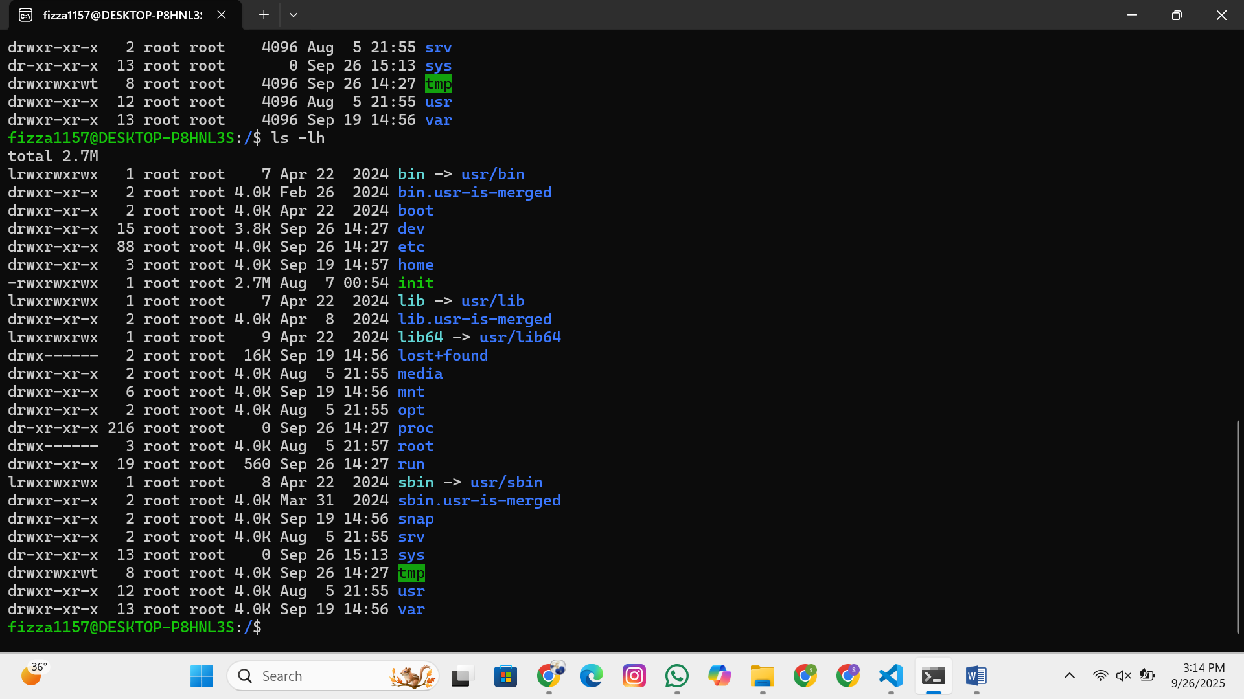

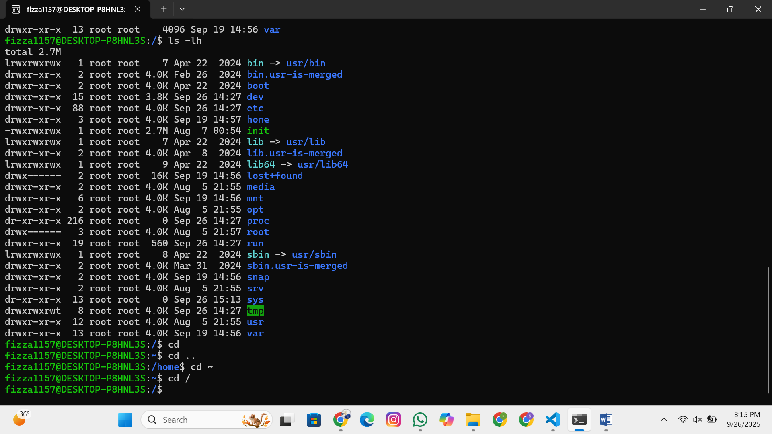

## Part 3: File and Directory Operations

**\*\*3.1 Creating and Managing Files/Directories**

**Commands to demonstrate:**

mkdir

myl

ab

2

#

C

re

a

te

dire

c

tory

mkdir

-

p

test

/

su

b

/

dir

#

C

re

a

te

nested

dire

c

tories

tou

c

h

file

1

.

txt

#

C

re

a

te

empty

file

tou

c

h

file

2

.

txt

file

3

.

txt

#

M

ultiple

files

#

T

ext

editors

introdu

c

tion

n

a

no

hello

.

txt

#

S

imple

text

editor

#

OR

e

c

ho

"

H

ello

L

inux

"

!

>

hello

.

txt

#

R

edire

c

t

output

to

file

**File viewing commands:**

ca

t

hello

.

txt

#

D

ispl

a

y

file

c

ontents

less

hello

.

txt

#

Pa

ge

through

file

he

a

d

hello

.

txt

#

F

irst

10

lines

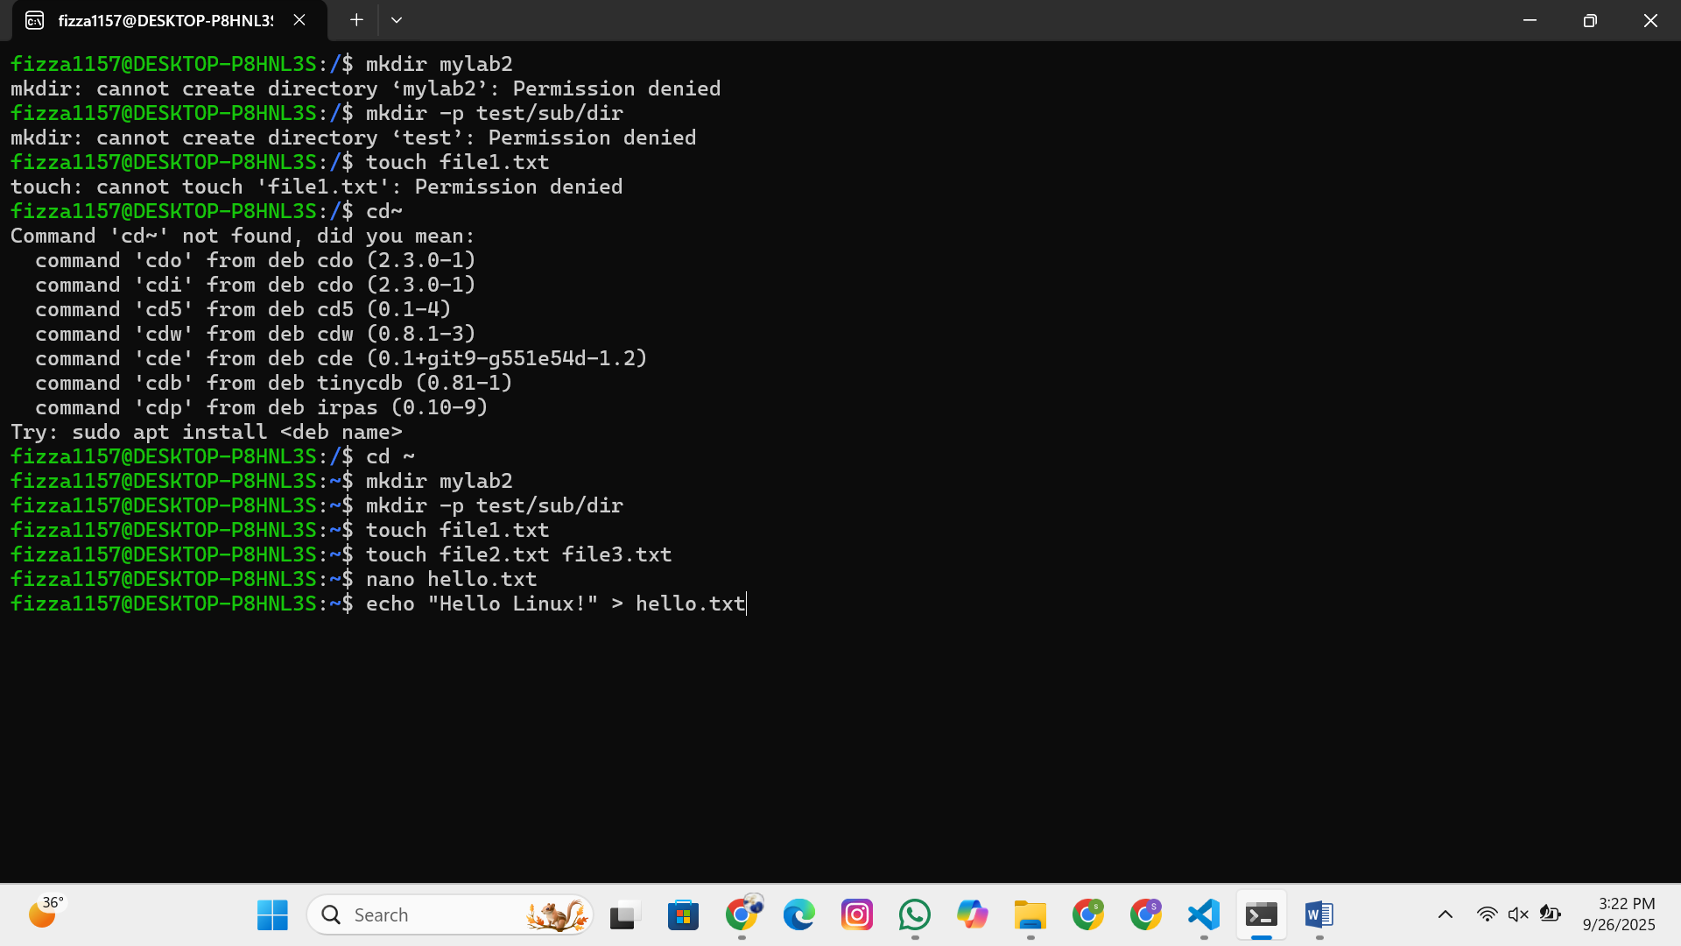

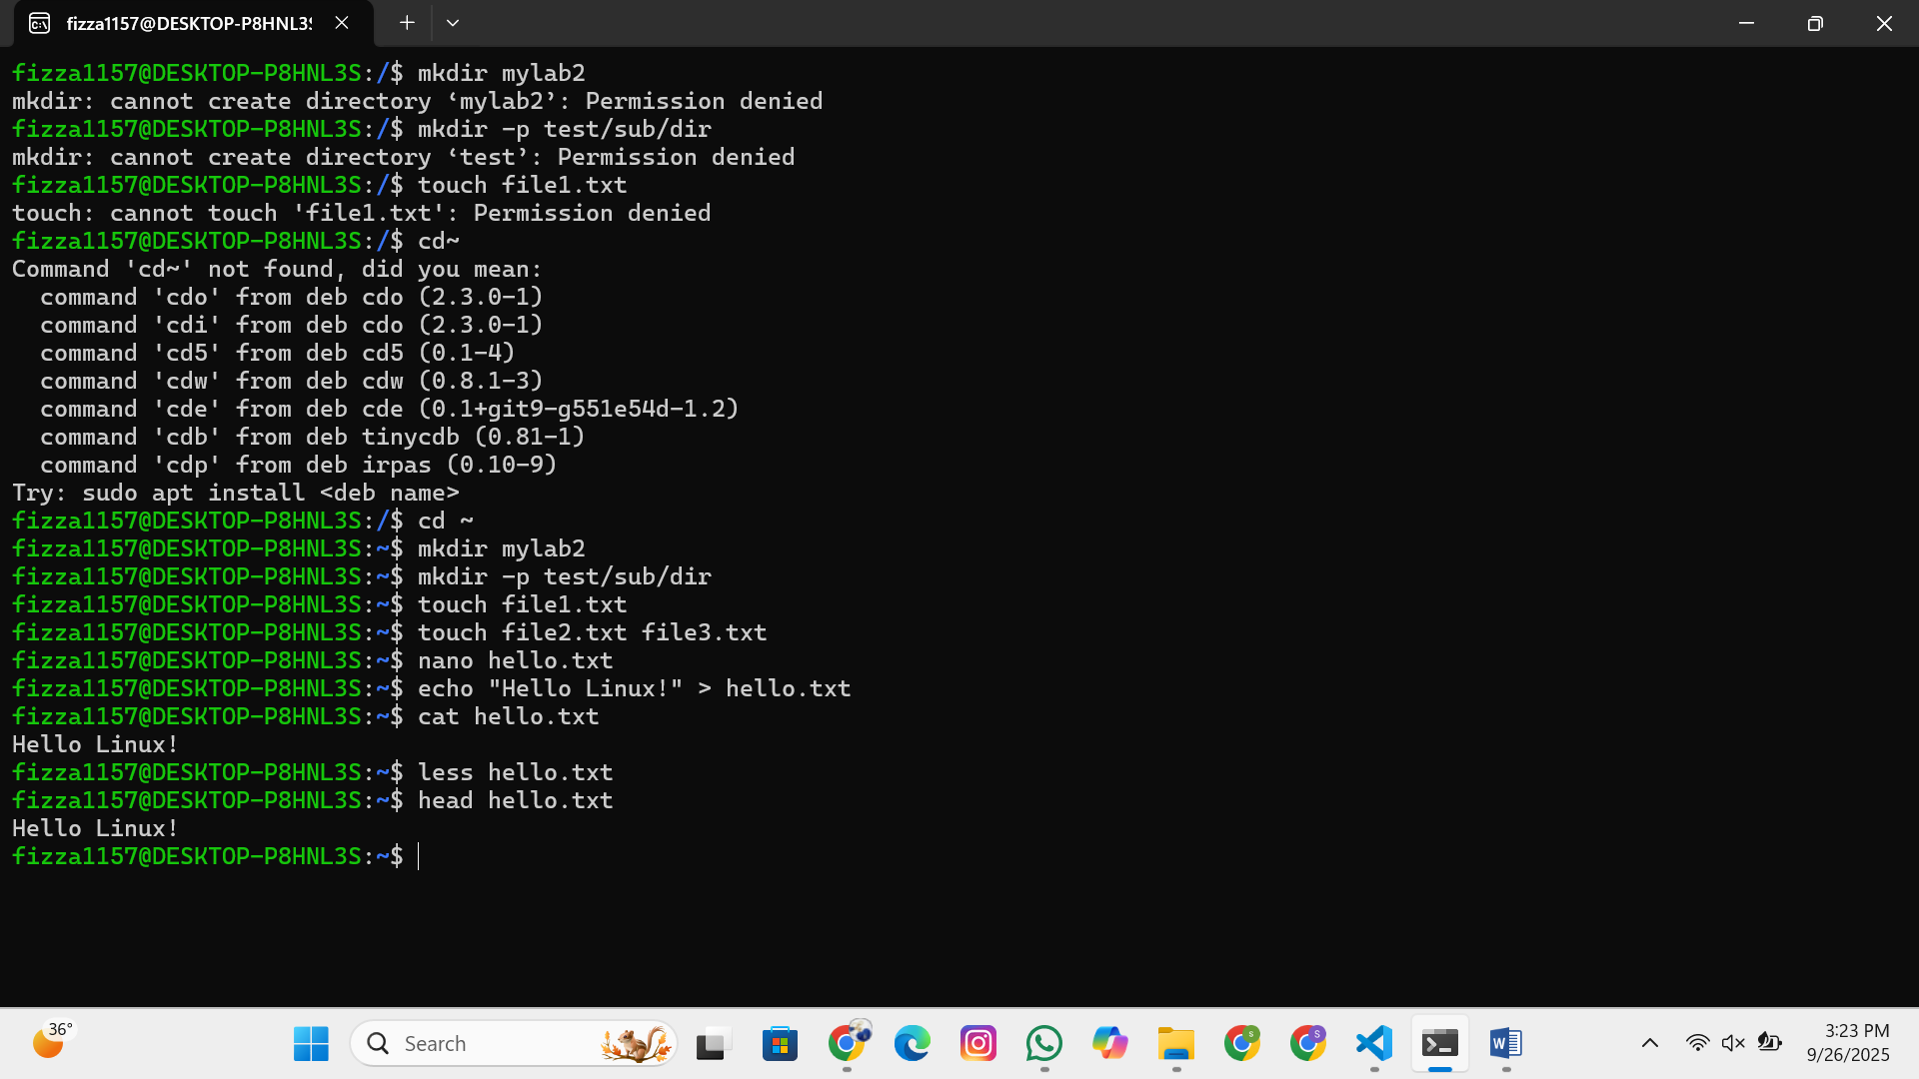

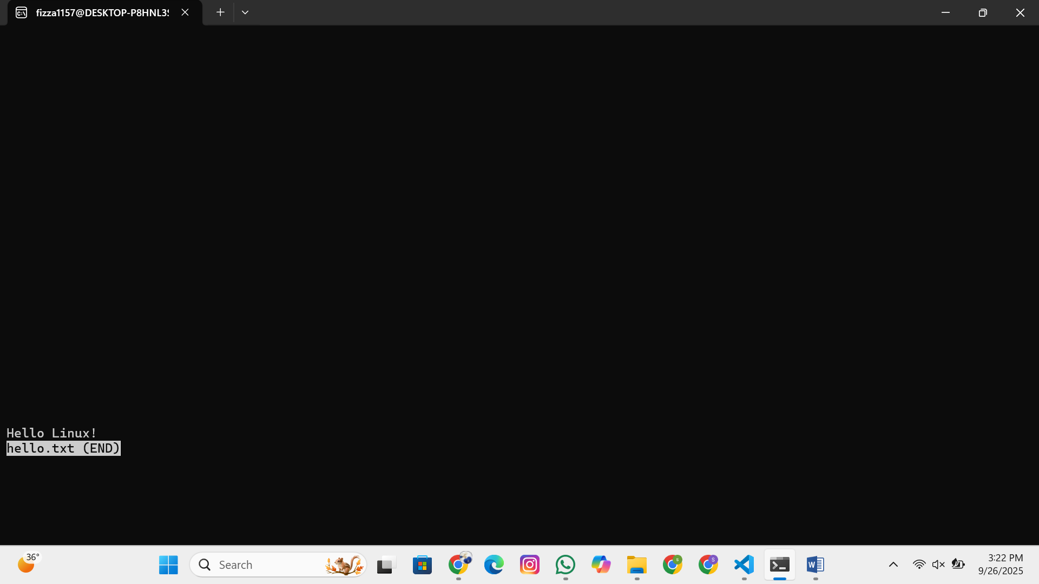

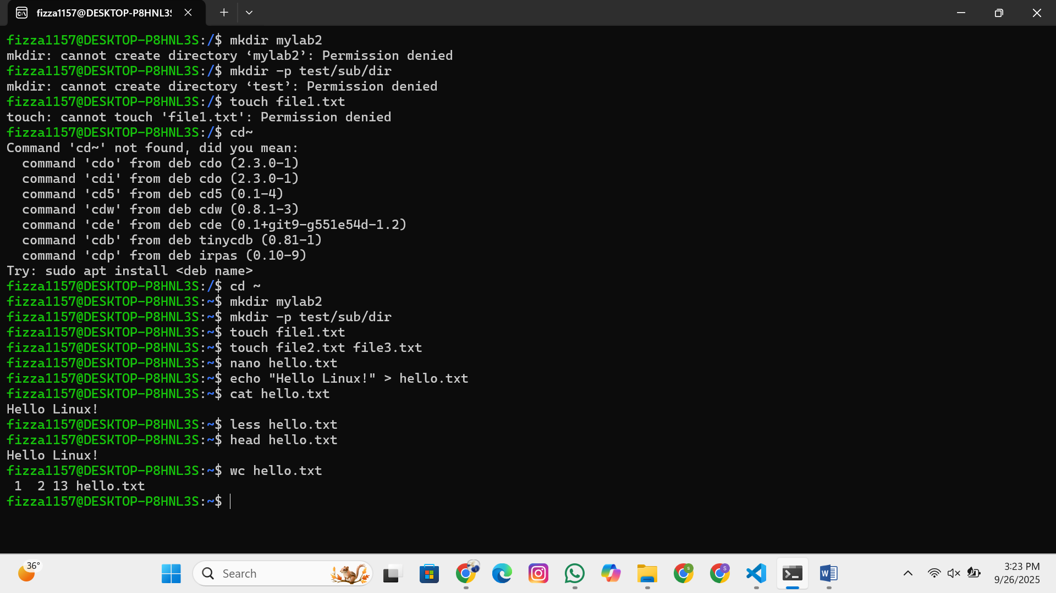

t

a

il

hello

.

txt

#

La

st

10

lines

w

c

hello

.

txt

#

W

ord

c

ount

### 3.2 Copying, Moving, and Deleting

**Commands to practice:**

c

p

hello

.

txt

bac

kup

.

txt

#

C

opy

file

c

p

-

r

myl

ab

2

myl

ab

2

_

bac

kup

#

C

opy

dire

c

tory

re

c

ursively

mv

bac

kup

.

txt

ren

a

med

.

txt

#

M

ove

/

ren

a

me

file

rm

ren

a

med

.

txt

#

R

emove

file

rm

-

r

myl

ab

2

_

bac

kup

#

R

emove

dire

c

tory

rmdir

empty

_

dire

c

tory

#

R

emove

empty

dire

c

tory

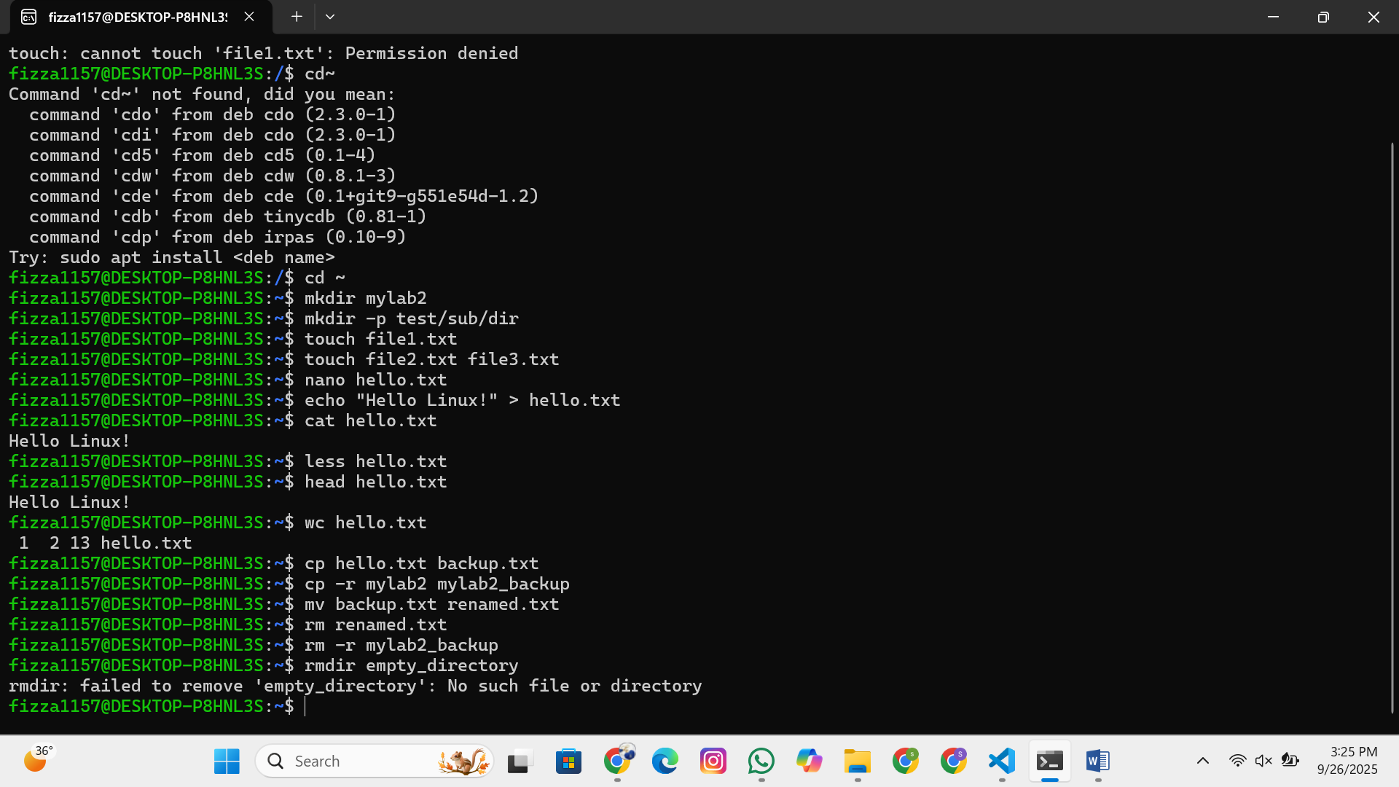

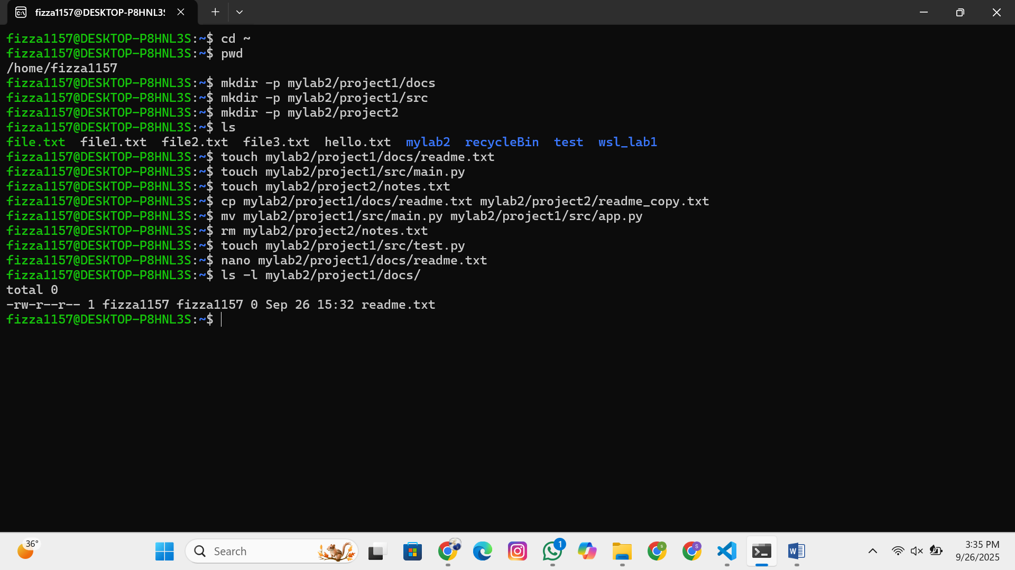

**Hands-on Exercise:** Students create a directory structure, add files, and practice file operations.

## Part 4: File Permissions and Ownership

### 4.1 Understanding File Permissions

**Concepts to Cover:**

Permission types: read (r), write (w), execute (x)

Permission groups: user (u), group (g), others (o)

Numeric notation: 755, 644, etc.

**Commands to demonstrate:**

ls

-

l

#

V

iew

permissions

c

hmod

755

file

.

txt

#

C

h

a

nge

permissions

(

numeri

c

)

c

hmod

u

+

x

file

.

txt

#

A

dd

exe

c

ute

permission

for

user

c

hmod

g

-

w

file

.

txt

#

R

emove

write

permission

for

group

c

hown

user

:

group

file

.

txt

#

C

h

a

nge

ownership

(

if

a

ppli

cab

le

)

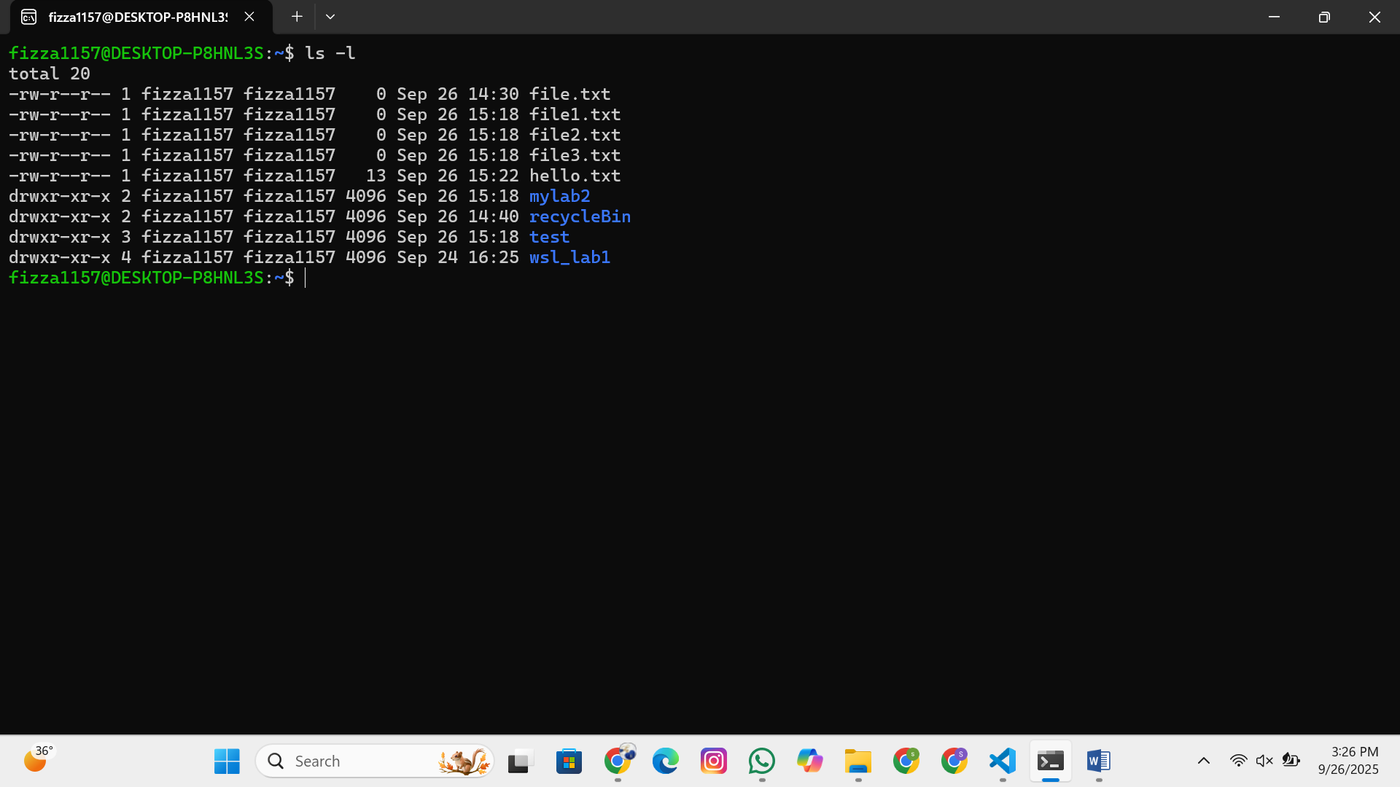

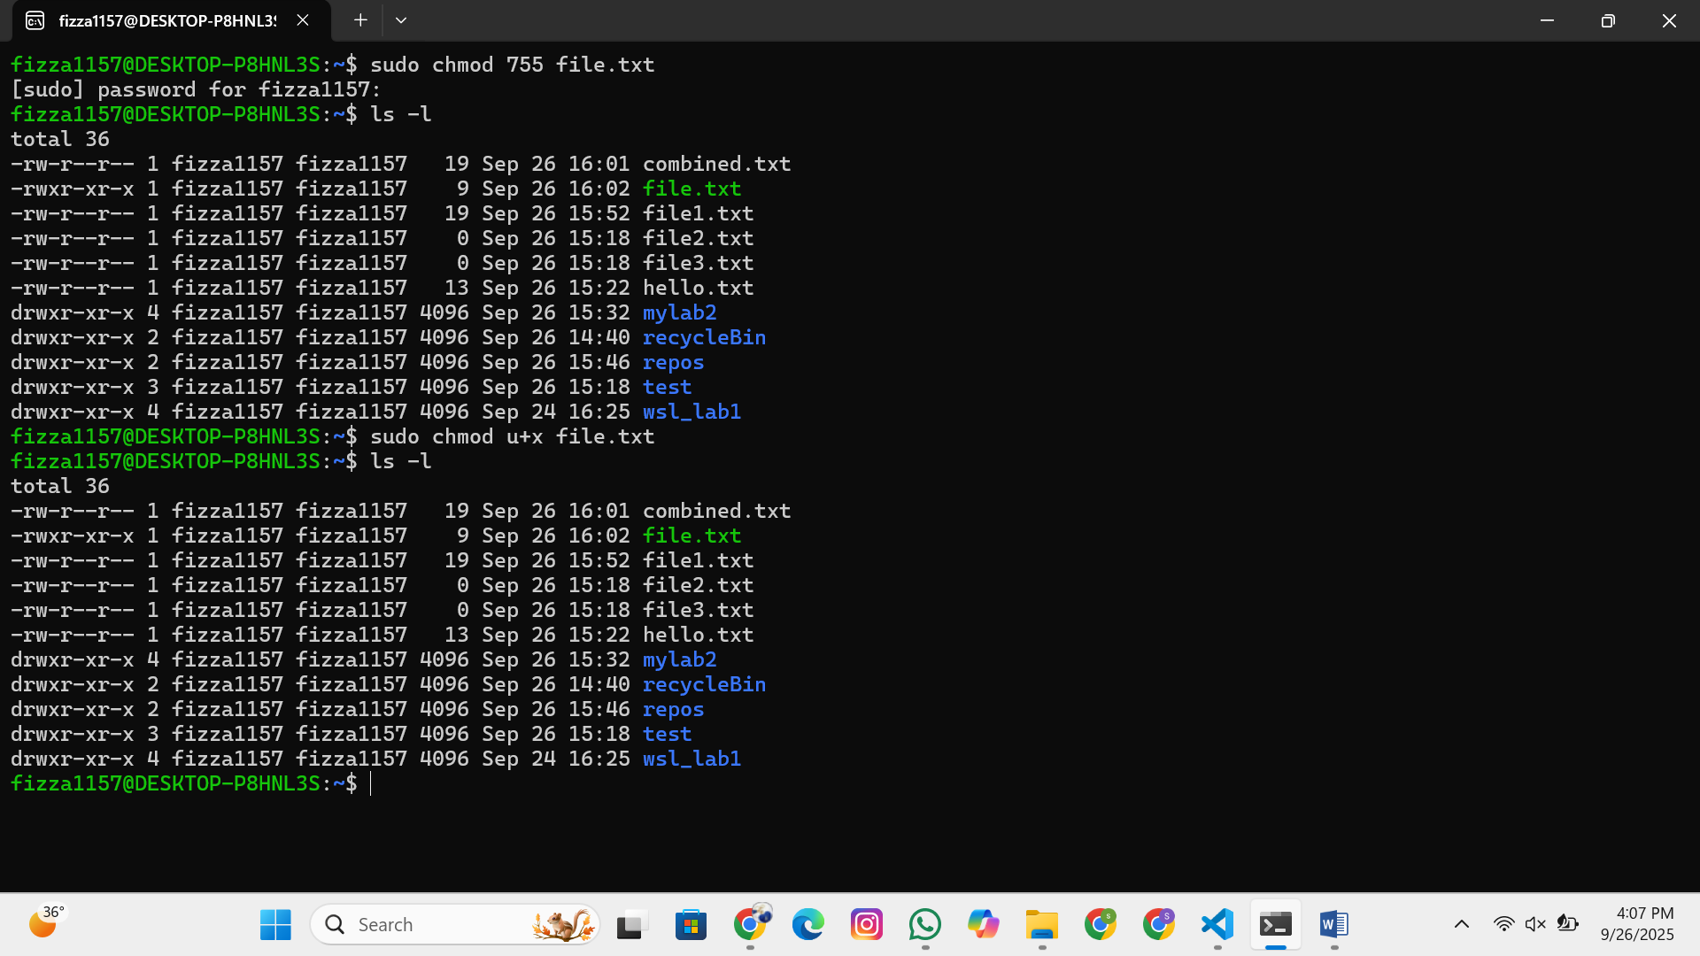

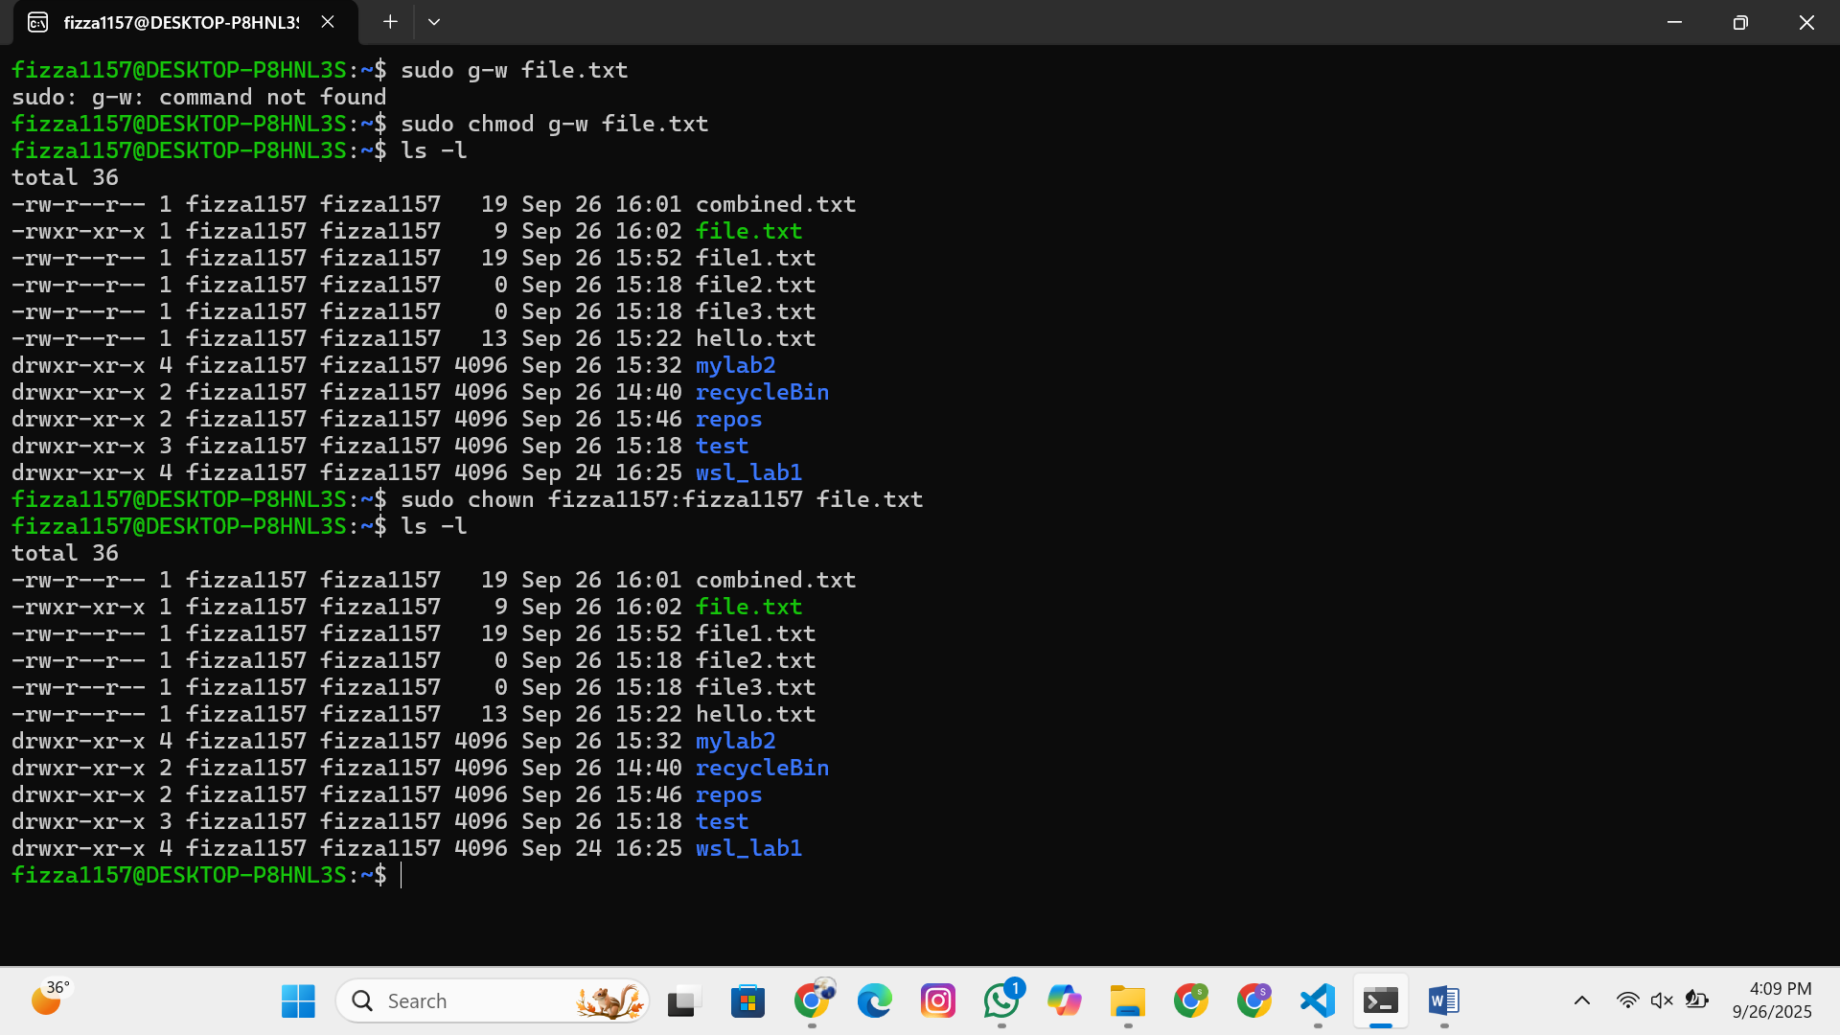

## Part 5: Text Processing and Utilities

### 5.1 Essential Text Commands

**Commands to demonstrate:**

grep

"

p

a

ttern

"

file

.

txt

#

S

e

a

r

c

h

for

p

a

tterns

grep

-

i

"

p

a

ttern

"

file

.

txt

#

Ca

se

-

insensitive

se

a

r

c

h

grep

-

n

"

p

a

ttern

"

file

.

txt

#

S

how

line

num

b

ers

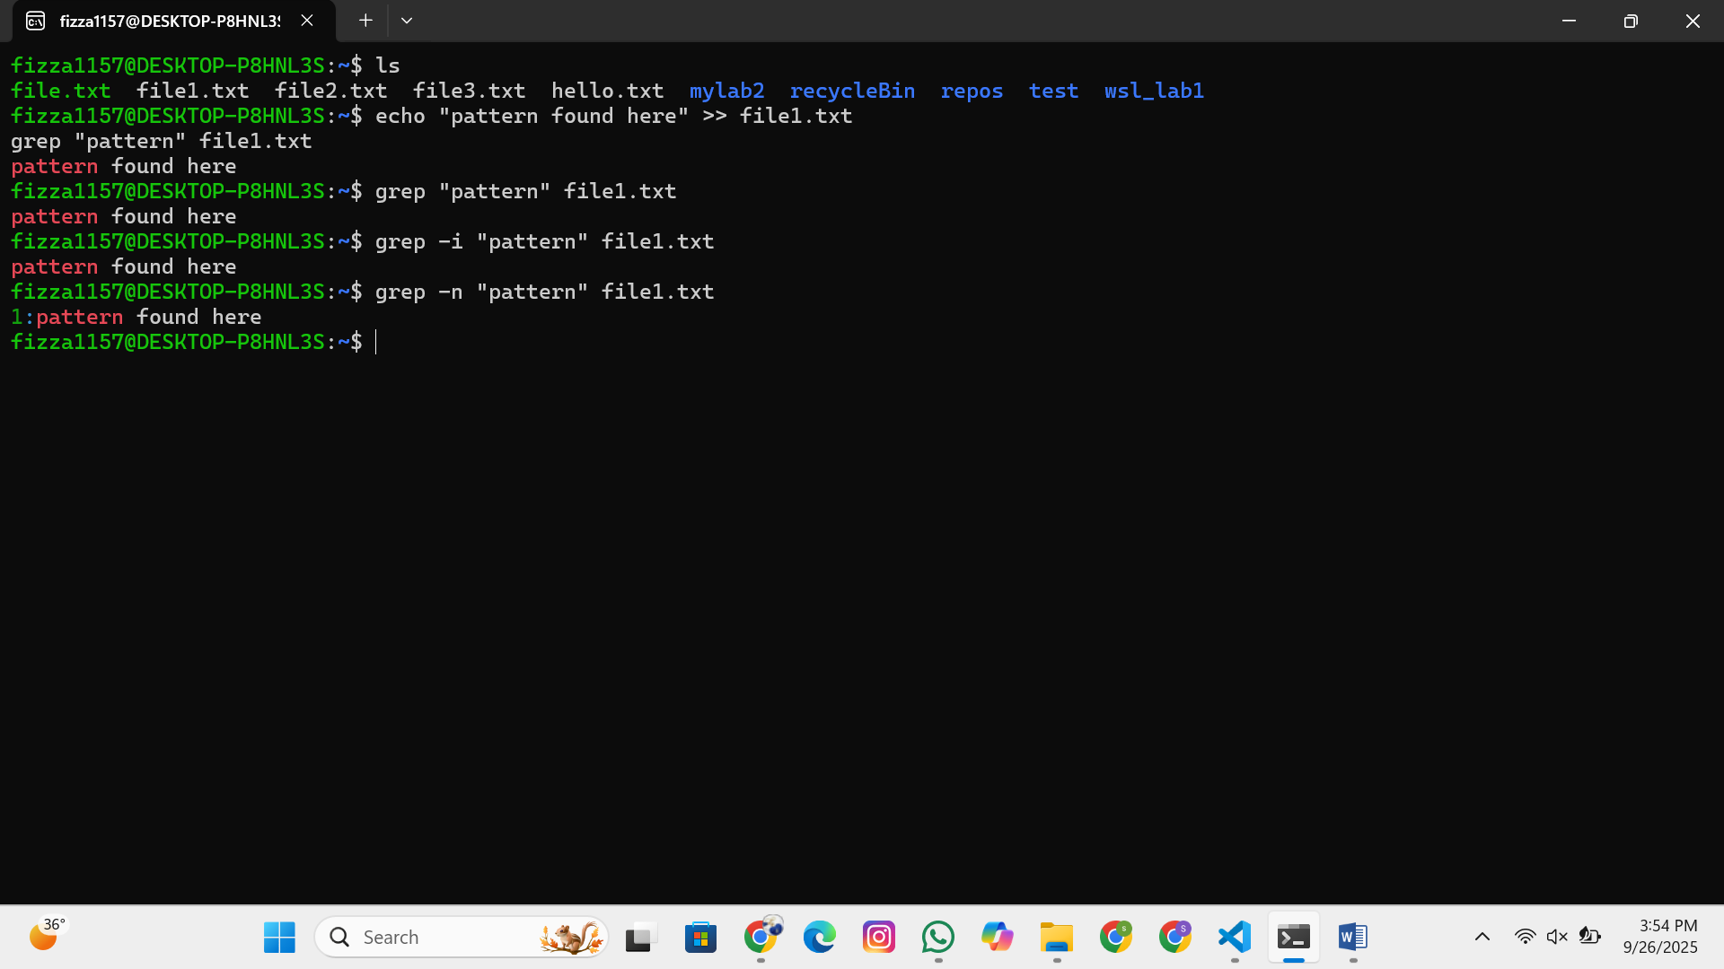

### 5.2 Pipes and Redirection

**Concepts and commands:**

ls

-

l

|

grep

".

txt

"

#

P

ipe

output

ca

t

file

1

.

txt

file

2

.

txt

>

c

om

b

ined

.

txt

#

R

edire

c

t

output

e

c

ho

"

new

line

"

>>

file

.

txt

#

A

ppend

to

file

sort

file

.

txt

|

uniq

#

C

h

a

in

c

omm

a

nds

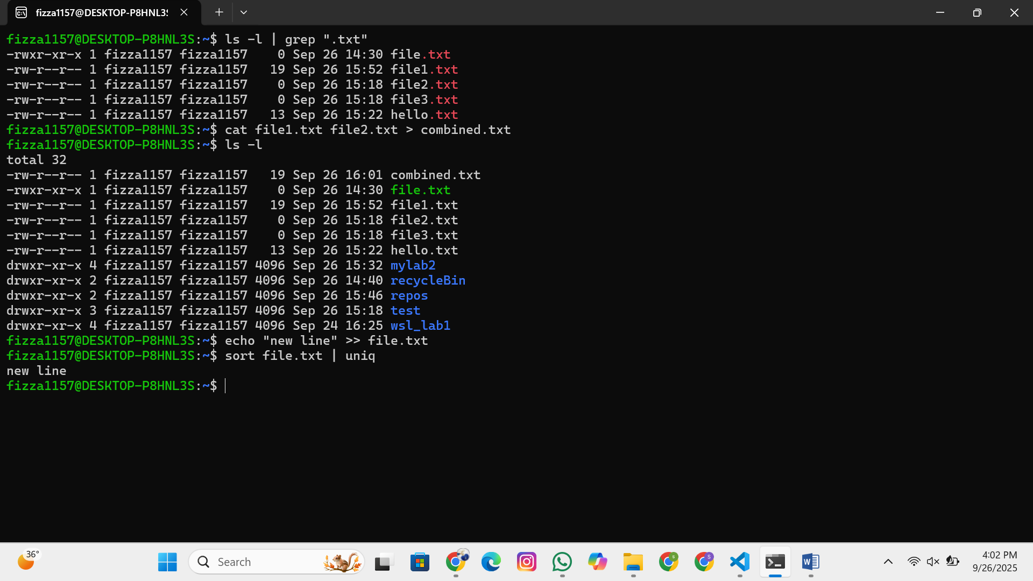

## Part 6: Introduction to Processes

### 6.1 Understanding Processes

**Concepts to Cover:**

What is a process?

Process ID (PID)

Parent-child relationships

Process states

**Commands to demonstrate:**

ps

#

S

how

c

urrent

pro

c

esses

ps

a

ux

#

D

et

a

iled

pro

c

ess

list

ps

-

ef

#

F

ull

form

a

t

listing

pstree

#

P

ro

c

ess

tree

top

#

R

e

a

l

-

time

pro

c

ess

viewer

htop

#

E

nh

a

n

c

ed

pro

c

ess

viewer

(

if

a

v

a

il

ab

le

)

kill

PID

#

T

ermin

a

te

pro

c

ess

b

y

PID

kill

a

ll

pro

c

ess

_

n

a

me

#

K

ill

pro

c

esses

b

y

n

a

me

pkill

p

a

ttern

#

K

ill

pro

c

esses

m

a

t

c

hing

p

a

ttern

